TASK 4 - HashTable

Hello,
I checked your problem. Indeed, I verified that the issue exists in the current version of the HashTable implementation. This problem is easy to repair and I give you some steps, screenshot and repair project.
- Change parameter
  - Go to HashTable.cs
  - Find row 162
  - Change parameter Capacity to newCapacity
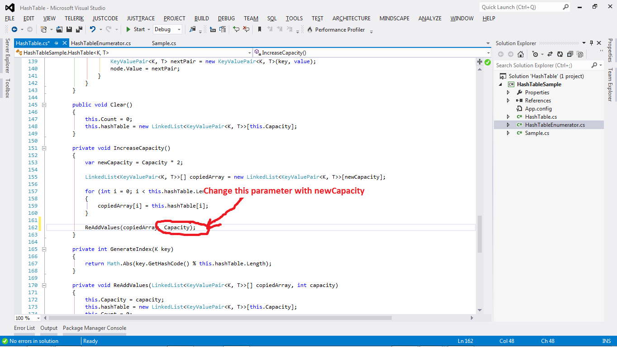
- Add toString method
  - Go to HashTable.cs
  - Find row 65
  - Replace this.hashTable[hashedIndex].First with this.hashTable[hashedIndex].First.Value.Key.ToString()
  - Replace key with key.ToString()
  - Make steps C and D for row 69
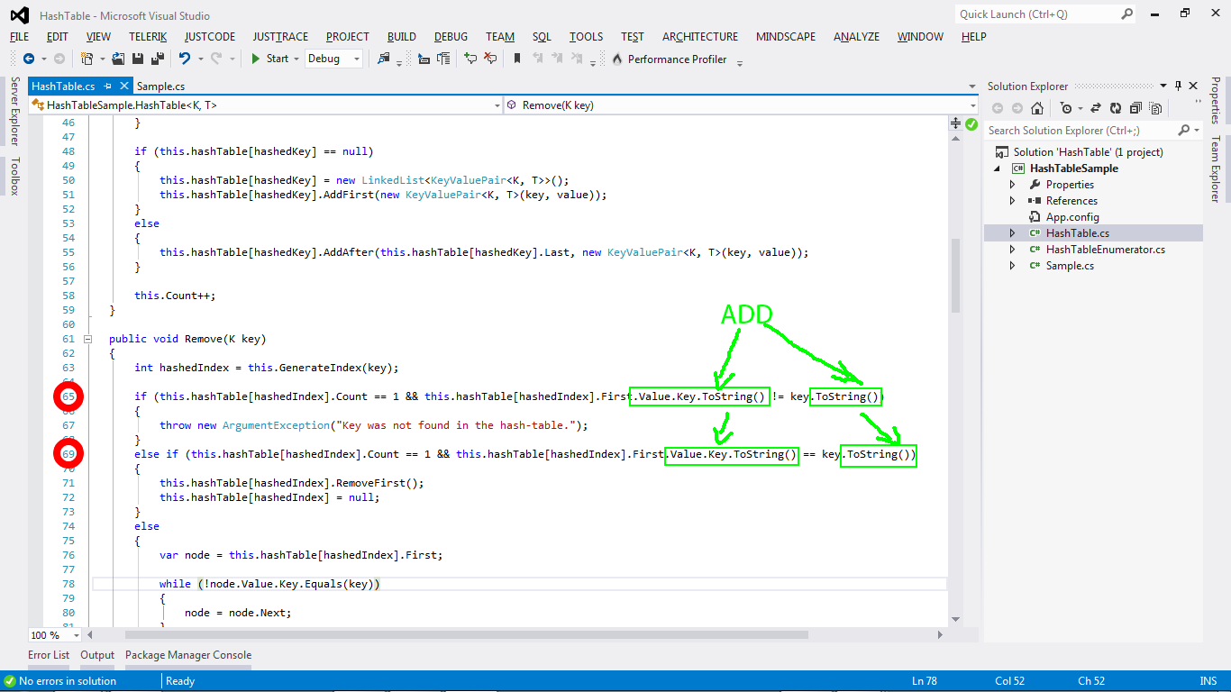
I hope this information helps. I will be glad to assist you further.
Regards XXX

